Women of Achievement 教学设计

Reading & Writing Session - A Student of African Wildlife

设计人：苏晴
教学年级班级：高一1班（文科班）
课型：英语读写课程
教学内容：Module 4, Unit 1
教学时间：40分钟

教材分析：本节课是人教课标版必修4第一单元 Women of Achievement 的阅读语篇，中心话题是介绍一位女性野生动物保护者— Jane Goodall，从其工作的内容，困难，和取得的成就等方面作了详细介绍。本单元通过介绍杰出女性提高同学们对妇女的社会角色的认识，培养学生（尤其是女同学的）自信心，事业心和社会责任感 ，通过对语篇的分析使学生了解英语人物描写的特点和方法。

教学目标：
- 知识目标：词汇- behave，observe，worthwhile，outspoken
- 能力目标：a. 培养学生的阅读能力,使他们能熟练运用阅读技巧,提高获取信息和处理信
息的能力
b. 培养学生的人物描写能力，通过对语篇的分析和读后的探讨，使同学们掌
握如何描述人物特征
- 情感目标：通过学习,唤起学生理解动物、尊重动物和保护动物的意识。通过学习主人公乐观的人
生态度, 使学生受到鞭策和鼓舞, 从而建立正确的性别观和价值观

教学设计：
步骤 | 目的 | 教师活动 | 学生活动
1. Warming-up (Task 1)  Game: Guess who it is!  1 min | 引入话题，调动气氛 | Make an example of the guessing game.  Describe a person and ask students who it is. | Listen, follow the teacher and take a guess.
1. Warming-up (Task 2)  Brainstorm adj. used to describe a person and play the game  4 mins | 回顾词汇，通过游戏感受学习任务 | Write down words which are not on PPT.  Listen to students’ description and provide help if they need. | Refresh their memory on the adjectives learned to describe a person and speak them out.  Three students describe three people to the class and let the rest guess who they are referring to.
1. Warming-up (Task 3)  Show pictures of great women and briefly introduce them  1 min | 利用图片引出对伟大女性的介绍，明确主题 | Present pictures of great women to students and clarify our main theme of the class. | Follow the teacher and answer if they recognize the women presented, what their names are, what they do and what they are famous for.
2. Pre-reading (Task 4)  Choose correct words to fill in the sentences  2 mins | 检查预习情况，防止阅读中生词影响理解 | Present the test, give instruction and check students’ answers. | Read the sentences and choose the correct word to fill in the blanks.
3. While-reading (Task 5)  Find key words  3 mins | 通过关键词掌握文章主题意思及人物关键信息 | Present the requirements of their reading task and encourage students to find important information as fast as they can.  Check answers. | Skim the passage and find key info according to the hints in the table
3. While-reading (Task 6)  Find key sentences  3 mins | 通过段落关键句分析文章层次，使同学们对文章走向有基本认识 | Emphasize tips of locating key sentences.  Invite students to give their answers. | Scan the passage and find key sentences to grasp the main idea of the reading material.
3. While-reading (Task 7)  Fill in the mind map while listening to the recording  10 mins | 听录音仔细阅读，保证同学们阅读速度，同时熟悉词汇和文章细节，用思维导图引导学生分析文章结构 | Explain the structure of the mind map and how to complete it.  Walk around and provide help if necessary. | Listen to the recording and read the passage carefully.  Complete the mind map.
4. Post-reading (Task 8)  Q & A  4 mins | 通过对开放性问题的回答，启发学生思考，培养其形成良好的自主思维模式 | Encourage students to form their own answers and invite students to present their version. | Read the questions, relate the question to the gist of the passage and provide their answers.
4. Post-reading (Task 9)  Group work: describe the person in the picture  6 mins | 巩固分析过的人物描写类文章的语篇特征，并应用于语言输出 | Guide the students to conclude the method of describing a person.  Walk around the class and provide help if needed. | Group discussion to make a vivid description of the person in the picture.
4. Post-reading (Task 10)  Discuss and conclude  5 mins | 总结人物描写方法，突出强调应描绘人物特征 | Provide hints on how to make a good description of a person. | Group discussion to consolidate their understandings.
5. Assignment  Write a composition  1 min | 落实课后作业 | Clarify the requirements of the assignment. | Choose a writing task they are interested.

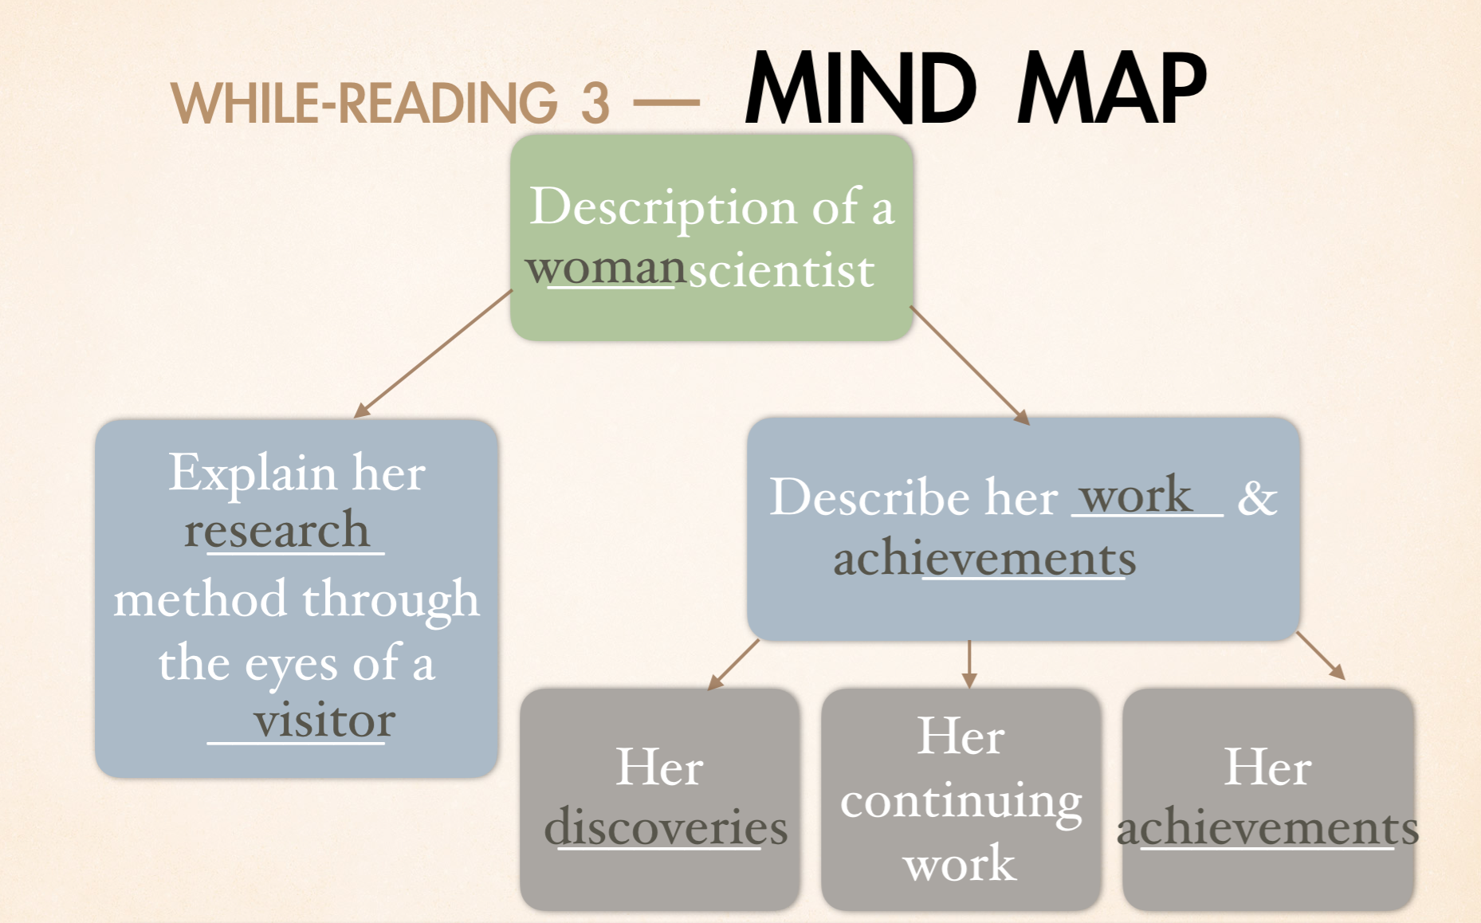

A STUDENT OF AFRICAN WILDLIFE

It is 5:45 am and the sun is just rising over Gombe National Park in East Africa.Following Jane's way of studying chimps, our group are all going to visit them in the forest.Jane has studied these families of chimps for many years and helped people understand how much they behave like humans.Watching a family of chimps wake up is our first activity of the day.This means going back to the place where we left the family sleeping in a tree the night before.Everybody sits and waits in the shade of the trees while the family begins to wake up and move off.Then we follow as they wander into the forest. Most of the time, chimps either feed or clean each other as a way of showing love in their family. Jane warns us that our group is going to be very tired and dirty by the afternoon and she is right. However, the evening makes it all worthwhile.We watch the mother chimp and her babies play in the tree.Then we see them go to sleep together in their nest for the night.We realize that the bond between members of a chimp family is as strong as in a human family.
Nobody before Jane fully understood chimp behavior. She spent years observing and recording their daily activities.Since her childhood she had wanted to work with animals in their own environment. However, this was not easy.When she first arrived in Gombe in 1960, it was unusual for a woman to live in the forest.Only after her mother came to help her for the first few months was she allowed to begin her project. Her work changed the way people think about chimps.For example, one important thing she discovered was that chimps hunt and eat meat. Until then everyone had thought chimps ate only fruit and nuts.She actually observed chimps as a group hunting a monkey and then eating it.She also discovered how chimps communicate with each other, and her study of their body language helped her work out their social system.
For forty years Jane Goodall has been outspoken about making the rest of the world understand and respect the life of these animals.She has argued that wild animals should be left in the wild and not used for entertainment or advertisements.She has helped to set up special places where they can live safely.She is leading a busy life but she says:"Once I stop, it all comes crowding in and I remember the chimps in laboratories. It's terrible. It affects me when I watch the wild chimps.I say to myself,'Aren't they lucky?" And then I think about small chimps in cages though they have done nothing wrong.Once you have seen that you can never forget ..."
She has achieved everything she wanted to do: working with animals in their own environment, gaining a doctor's degree and showing that women can live in the forest as men can.She inspires those who want to cheer the achievements of women.

