思维可视图在教学中的应用
——听龚亚夫讲座
姓名：王橙橙
疫情期间，很多的学习以网上公益的形式展开，有幸听了龚亚夫关于思维可视图的讲座，收益颇多。现将讲座笔记和听课时的想法与感受记录如下：
- 思维品质thinking positions
- 核心素养要求与英语课标要求
- 培养思维品质成为教师共识
- 尚缺乏具体定义、内容与例证（通过哪些途径培养，没有定论）
- 对分类方法与定义的不同理解（不同人对思维能力有不同解读）
- 教师需要学习使用有效的工具（培养思维能力的方式局限于mind-map,并不广泛）

- 关于思维品质的几个问题
- 对布鲁姆学习目标范畴的认识
Affective, psychomotor and cognitive(局限于认知上的)
- 布鲁姆目标分类的不同看法
not happen in a lockstep, sequential manner,(学习思维并不一定是从低到高的顺序)
- 思维品质与学习能力的关系
Learning is product of thinking（……就是……）
- 英语学科对于发展思维品质的特殊之处
Testing hypothesis (science)， patterns (math), perspectives (history)…
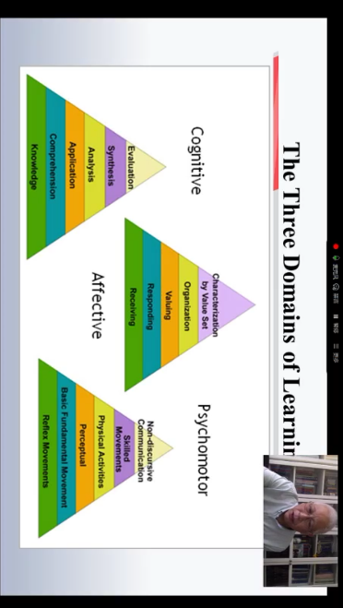
三、Thinking about thinking
Thinking doesn’t happen in a lockstep, sequential manner, systematically progressing from one lever to the next. It is much messier, complex, dynamic, and interconnected than that.
(Ritchhart, Church & Morrison, 2011)
此时注意：设计思维能力活动时需了解，思维并不是按部就班的，而是更加复杂。
Understanding is a chief goal
In the preceding discussion of Bloom’s taxonomy, we made the argument that understanding isn’t a type of thinking one does but is in fact a chief goal thinking. As most teachers are aware, understanding is one of the major thrusts of current educational practices.
(Ritchhart, Church & Morrison, 2011, p8)
思维品质 thinking dispositions（不仅包含逻辑思维）
思维品质往往是由品格决定的
Judgement is based on values
(思维方式决定价值判断)
正向思维（积极思维）方式
Positive psychology (character strengths and values)
Fixed mindset---Growth mindset（成长的思维方式，能发展学习能力，变得更加聪明）
学习能力与思维能力密不可分
Learning strategies
Lower and higher-order thinking skills
思维品质与学习能力
任何一个学科的能力都要在学生的思维活动中获得发展，离开思维活动，无所谓学科能力可言。因此一个学生某学科能力的结构，应当包含体现个体思维的个性特征及个体思维品质。
培养思维能力也是在培养学习能力
（林崇德，2015）
Thinking and learning
If we want to support students in learning, and we believe that learning is a product thinking, then we need to be clear about what it is we are trying to support.
(Ritchhart, Church & Morrison, 2011, p7)
基于此，作者提出
社会文化目标：行为规范与伦理美德，社会知识与学科融合，多元文化与国际理解
认知思维目标：正向的思维方式，多层次思维能力，学习策略与能力
语言交流目标：语言运用知识，听说读写技能，语言交流策略
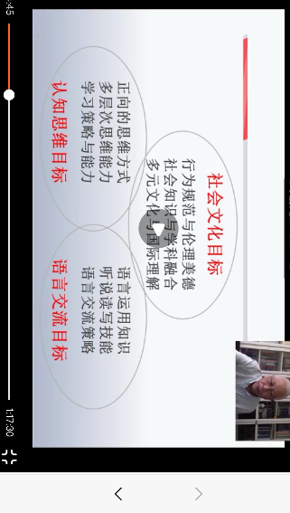
- 青少年教育与成长
有三个问题需要了解：
- 有哪些思维能力需要培养及其例证；
- 通过什么任务活动能培养这些思维能力；
- 思维品质中既有认知的、逻辑的，也有情感的、态度的，后者可以统称为“思维方式”
发展学生思维能力任务活动
Analyze: 1. Comparison; 2. contrasting; 3. classifying; 4. Sorting; 4. Sequencing

- 思维可视图-有效的工具
Graphic organizers 思维结构图 （mind-map是其中之一）
Thinking maps 思维路线图

Graphic organizers
A graphic organizer, also known as a knowledge map, concept map, story map, cognitive organizer, advance organizer, or concept diagram is a pedagogical tool that uses visual symbols to express knowledge and concepts through relationships between them.
Wikipedia
Graphic organizers are effective in helping readers develop text structures awareness by visually representing the structure of academic material and processing content-area readings.
(blackhowwicz & Ogle, 2008)
“…visual devices that depict information in a variety of ways. Most commonly, they employ lines, circles, and boxes, to form images which depict four common ways information is typically organized; hierarchic, cause/effect, compare/contrast, and cyclic(循环) or linear sequences（线性）. These images serve as visual cues designed to facilitate communication and/or understanding of information by showing how essential information about a topic is organized.”
(Ellis and Howard, 2005, p.1)

Cognitive structure
…learning occurs when new material is related to relevant ideas that are already present in the existing cognitive structure. Graphic organizers can facilitate this process by provifing students a framework for relating existing knowledge to the new information learnt.
(Jasmeet Virk and Heather Wik, 2011)
E.g.比较图，鱼骨图
（对教材升华，改编，通过工具展示）
e.g. daily routine 现在教材只限每天干啥，几点干啥。
Cause and effect 为啥迟到？为啥睡太晚？为啥？将陈述性，描述性的东西变成思维逻辑的东西。
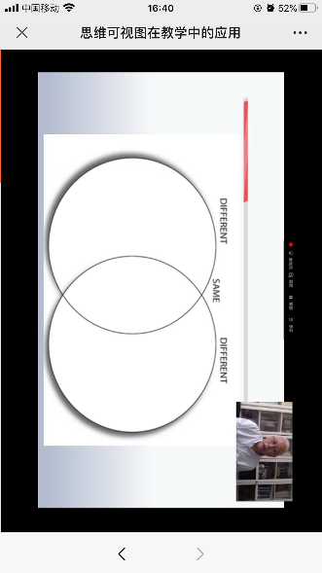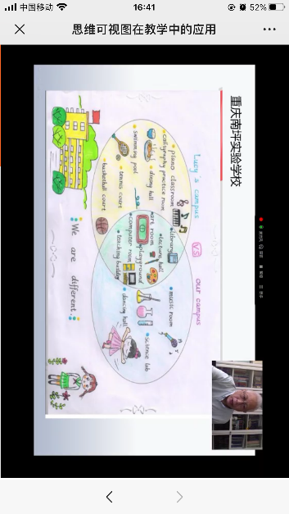
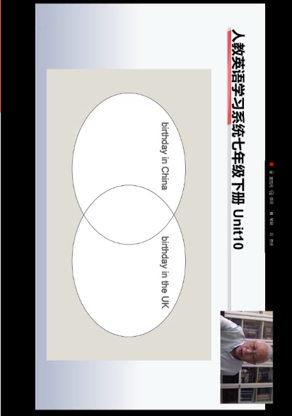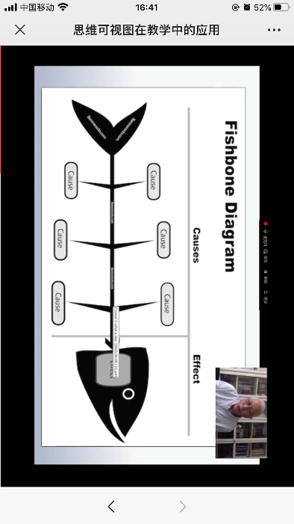
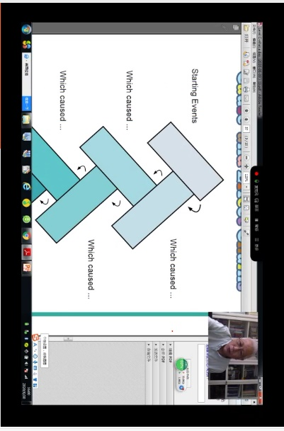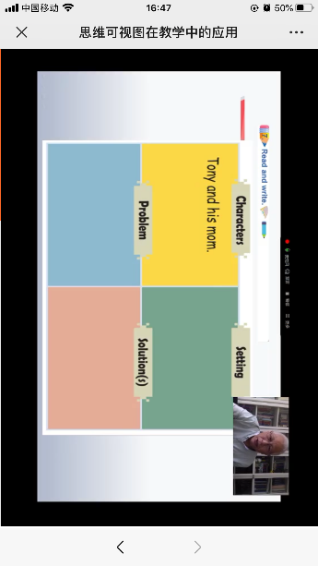

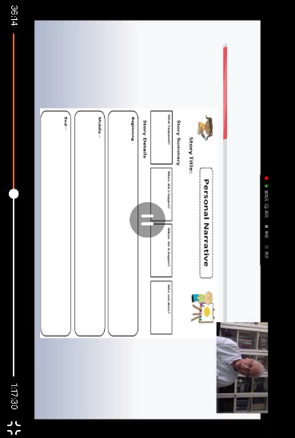

Thinking maps
Thinking maps are a language, … this language is grounded in and defined by eight everyday, interdependent cognitive processes we use as human begins to make sense of our world and through which we survive.
(Hyerle, 2011, p35)

e.g.8个类型（培养逻辑思维能力）
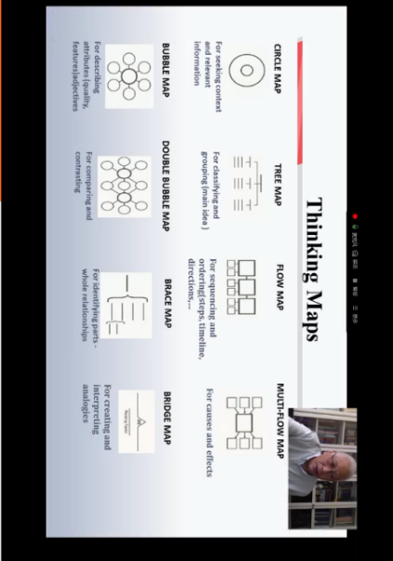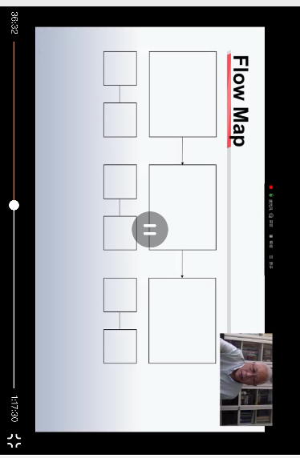
thinking maps
with thinking maps, all learners have a visual-verbal language of cognition, this enabling a deeper capacity to see, transfer, reflect upon, and improve their thinking abilities.
(Hyerle, 2011, p35)

五、思维可视图优点
- 简单明了地显示思维的结构与路线
- 清晰揭示出概念之间的关系与联系
- 使得教师能更清楚学生具体的问题（册子）
- 可以自然地将阅读与写作有机集合
- 可以将教学、学习和评价结合起来
- 提高教学、学习效率、避免靠刷题（单句准确性训练不好，综合运用）
- 培养学生元认知策略发展学习能力
- 有助于独立学习与合作学习的结合（小组活动，结对练习）
- 培养思维能力的同时发展学习能力

六、使用建议
不必写完整的句子，最好用语块（chunks）
小学和初中由教师选择graphic organizers
高中可以更多的使用thinking maps
不必拘泥于现有的固定模式，可以自行设计
不要担心小学生年龄小，从地段就可以使用

