Unit Five Visiting the moon 拓展阅读(Handout)
Name: ______________ Class: _______________
Learning objectives:
1. Practice reading and speaking.
2. Know more about the Moon and what people have done to explore it.
3. Learn the importance of developing science and technology and learn to keep up.

Learning steps:
Step 1 Lead in (Learn new words and review the words you’ve learned)
Remember the Chinese meaning for the new words.
explore [ɪkˈsplɔː(r)] 探索 astronaut [ˈæstrənɔːt] 宇航员 equipment [ɪˈkwɪpmənt] 装备
space 太空 spaceship 宇宙飞船 spacesuit 宇航服
lunar [ˈluːnə(r)] 月球的 solar [ˈsəʊlə(r)] 太阳的 global[ˈɡləʊbl] 地球的

Step 2 Extensive reading (拓展阅读) Before Jerry’s trip
A篇 Exploring the moon
What kinds of things are on the moon? Is there any water? Is there any life? To find the answers, humans and space crafts have visited the moon many times during the past 50 years. Here are some of the most important trips.
1969
Apollo 11 was a spacecraft. It was from NASA. It took astronauts to the moon for the first time. US astronaut Neil Armstrong was the first human to walk on the moon.
1972
Apollo 17 landed on the moon. It sent three astronauts there. They stayed three days on the moon. But no other humans have been to the moon since then.
2007
China sent Chang’e 1 into space. It was China’s first lunar probe (月球探测器). Chang’e 1 was in orbit for one year. It sent us a 3-D map of the moon’s surface (表面).
2007
SELENE is a spacecraft made by Japan. It orbited (绕轨道飞行) the moon for two years. It sent us data (数据) about the surface of the moon.
2008
India sent its own lunar probe, Chandrayaan-1, into space. It spent two years in orbit. It carried an important piece of equipment: the Moon Impact Probe (MIP, 月球撞击探测器). The MIP safely landed on the moon. It collected soil from the moon.
2013
Chang’e 3 landed on the moon successfully. It carried the moon rover (月球车) Yutu to the moon. Chang’e 3 found a new kind of mineral (矿物质). It proved (证明) there is no water on the moon.

Task 1(Pair-work): Draw the time axis (时间轴) on the handout.
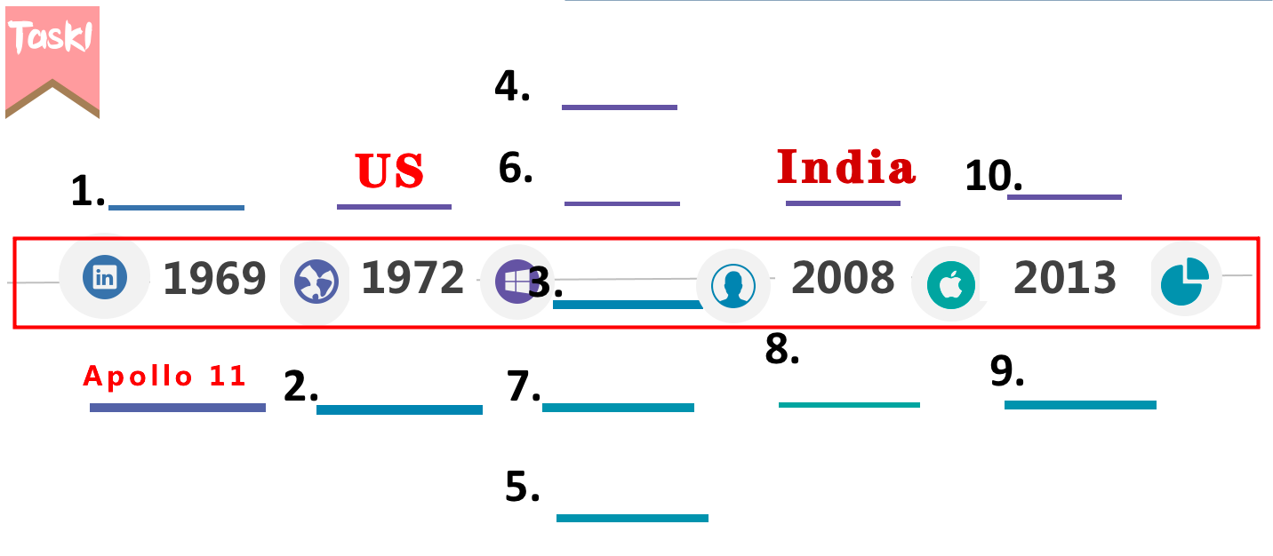
Task 2: Where can we probably read the passage? （ ）
A In a story book B In a science fiction
C In a newspaper D In a fashion magazine

B 篇What house will Jerry live in? Living on the moon
If Jerry could build a house on the moon, what would it look like?
Two Danish designers made a special house. They call it Lunark. It can be folded (折叠) and becomes smaller. When it is unfolded(展开), it becomes 5-6 times bigger. This makes it easier to take the house to the moon. Designers Sebastian and Karl-Johan got the idea from origami (折纸), a kind of Japanese art.
The house can hold two people. Inside it, there are two main areas. One is for sleeping and the other is for studying with a small toilet and a garden. The house has 328 solar panels(太阳能板). It weighs about 1700kg, as heavy as a car. And it is 3D printed. When people need to repair it, they can easily print new parts.
Later this year, they will test Lunark in northern Greenland (格陵兰岛北部) for three months. Northern Greenland is one of the most moon-like places on Earth. It is windy and as cold as -30 C. The designers will be cut off(切断联系) from the rest of the world. It will be almost like living on the moon. If it works, people might use it on the real moon in the future.
Task 1(Pair-work): Read the third paragraph. What does the house look like? What are there in the house? Draw a mind map(思维导图) with your partner.
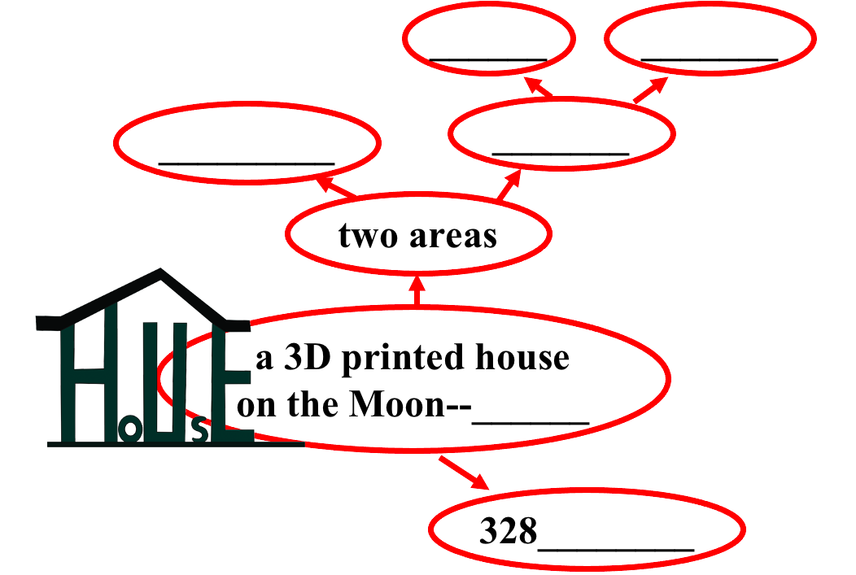

Task 2: Answer the question.
What will the designers do later this year?
________________________________________________________________________________

Step 3: Review Reading: Jerry’s trip
Fill in the blanks with the first letter given according to what you’ve learned in reading.
Jerry is very happy b__________ he will be one of the first students to travel into space. The s_________ will leave the Earth at 9 a.m. tomorrow. It will take them to the Moon. It will take them about four days to get there. There is no gravity, so they will have to tie t________ to beds so that they won’t float away in their sleep. W_________ gravity, bodies may get weak, so they will do exercise every day. When they arrive, Jerry is going to walk on the Moon. He will have to wear a s__________ to help him breathe since there is no air. He is going to take as many photos as he can if his camera still works up there.

Step 4 Post-reading activity: Having an interview. After Jerry’s trip
Group work: S1: Jerry S2-3: Jerry’s classmates S4-5: reporters S6: teacher
Jerry has come back from space. Two reporters from the school newspaper interviewed Jerry and his classmates about their trip to space. Teacher will make a conclusion(总结) at last. You can start your interview like this:
Reporter 1: Hello. We know you’ve just come back from space. We all want to know something about your trip.
Reporter 2: How long did it take to get to the Moon?
Jerry: ------
Reporter 1: How did you sleep? There is no gravity.
Classmate 1: ------
Reporter 2: What did you do on the Moon?
Jerry: ------
Reporter 1: How do you feel about your trip?
Classmate 2: -------
Reporter 2: Is it important for people to explore the Moon?
Teacher: The moon --- useful things, closest neighbor, a rest station to learn more about ----
(回答可借助补充阅读材料第一段)

Step 5 Conclusion
科学技术是第一生产力。坚持就是胜利!

Step 6 Homework. (手抄报)
Designers are working together to build houses on the Moon. Design your own house on the Moon. What does it look like? Draw it on your paper（A4）
Give a short introduction in complete sentences in English.
注意：1. Listening of Unit 5: The space hotel for reference听力部分太空酒店可供参考
2. The Simple Future Tense 句子使用一般将来时,语法部分一般将来时可供参考

补充阅读材料
C How much do you know about the moon?
In 1969, humans landed on the moon for the first time. Now, many other countries want to go there as well. Why? The moon has a lot of minerals (矿物质) and other useful things. We want to find out if we can use them. The moon is our closest neighbor in space. We can use it as a rest station (休息站). Then, we can learn more about other planets far away in space.
How big is the moon?
The moon is 3,474 kilometers in diameter (直径). It is about one-fourth the size of Earth. If Earth is the size of a basketball, the moon is the size of a tennis ball.
Gravity
The moon has much less gravity than Earth. If you can jump 1.5 meters on Earth, you can jump 9 meters on the moon.
What is the moon like?
The moon is very quiet. There is no sound there. There are a lot of grey rocks on it. The moon’s sky is always black.
How far is the moon?
Our moon is about 384,400 kilometers away from Earth. The total length of the Great Wall is about 21,200 kilometers. We would have to put about 18 Great Walls together to reach the moon!
Average temperature
Earth = 15 C
Moon = 123 C during the day, -233 C at night
Length of one day
Earth = 24 hours
Moon = about 648 hours
Length of one year
Earth = 365 days
Moon = about 27 days
D Exploring space promotes new inventions
Studying the moon is not just about exploring space. By studying the moon, scientists have created new technologies (科技). Later, they used these technologies to create some cool inventions (发明). These inventions help us live better lives. What are they? Let’s find out!
Nike Air 耐克
In 1960s, NASA scientists used a special material (材料) to make astronauts’ helmets (头盔). This material makes the helmets lighter. Later, scientist used this material to make shoes. This is the Nike Air. Such shoes are good for running. They are light and stable (稳定的).
Vacuum cleaner 真空吸尘器
Is there a vacuum cleaner in your home? It uses space technology. During the 1960s, NASA made a kind of drill (电钻). Astronauts used the drill to take rocks from the moon. Later, scientists used this technology to make vacuum cleaners.
Firefighters’ breathing systems 消防员呼吸系统
Astronauts may have some emergencies (紧急情况) in space. For example, they might find it hard to breathe in their spacesuits. Scientists made a special breathing system to solve2 this problem. Firefighters on Earth still use this same breathing system.

