Unit Seven It is raining 阅读(Handout)
Name: ______________ Class: _______________
Learning objectives:
1. Practice reading and speaking.
2. Go over weather and the present continuous tense. Know about different parts of postcards.
3. Learn to care about the weather in the world, and share life with friends.

Learning steps:
Step 1 Lead in (Learn new words and review what you’ve learned)
- Weather: _________, sunny, cloudy, windy, ___________
hot ________ warm __________ wet _________ (反义)

- Places in the world
city 城市 | country 国家 | continent 大洲
Beijing/Shanghai
Moscow
Toronto

- What are people doing?
In picture a Su Lin she is ______________ by the pool and drinking ________________.
In picture b Dave is climbing the _____________ with friends.
In picture c Jane is _______________ a letter.
They are all ____________________ and having a ___________ time.

Step 2 Reading 阅读 POSTCARD
- Before reading : How many parts does a postcard have?
邮编  postcode  _____________  ______________  ______________ | name of the receiver  收卡人姓名  address of the receiver  收卡人地址
  0
  2
  7
  5
  5
  1
  _______________________
  stamp
  邮票
- While reading: Check different parts of Su Lin’s and Dave’s postcards.

- Fast reading --- How many parts are there? Circle(圈出) different parts.
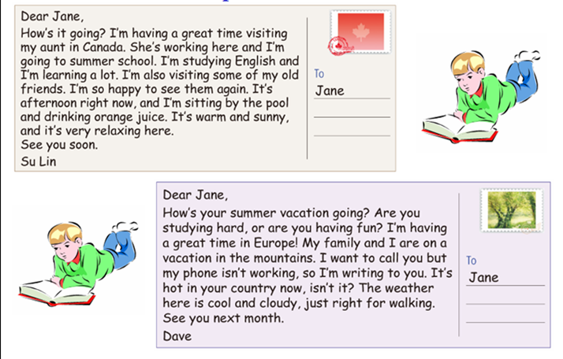
- Careful reading---Fill in the form according to different parts of a postcard.
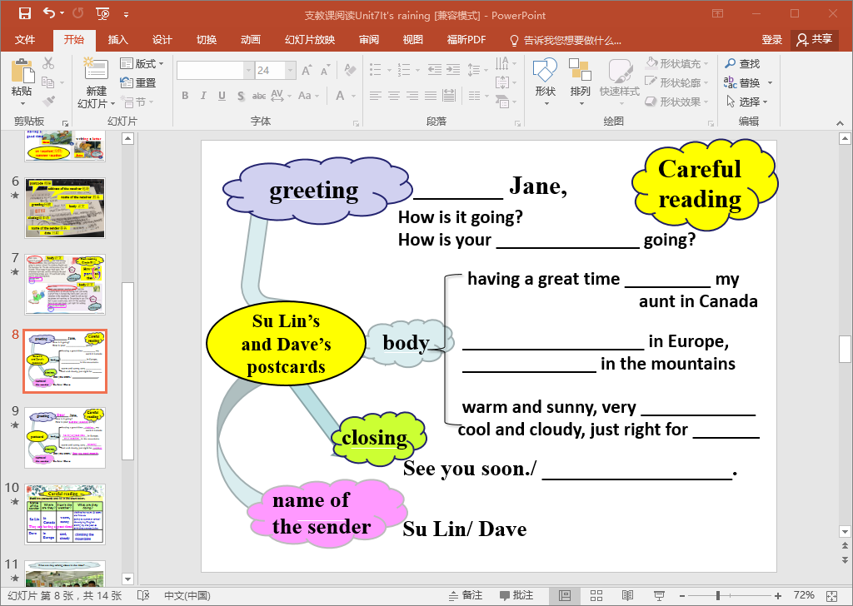
- Careful reading--- more detailed information
Name | Where are they? | How’s the weather? | What are they doing?
Step 3 Post Reading: Watch the video: a special postcard from Guangzhou.
Complete a spoken postcard to Ss in Guangzhou.

Step 4 Conclusion: Care about weather and always share your happiness with friends!
Step 5 Homework: Finish all blanks on handouts. Make a postcard.(可中文，注意明信片格式)

