看图造句练习卷
请根据图片，用所给的关键词造句。请按需加上冠词、介词、谓语动词、连词等。并使用动词和名词的正确形式。
U5单元
- I, glad, guest, host family
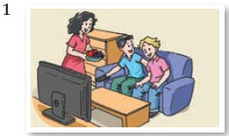
- visit, local school, make friends,
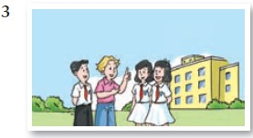
- we, already, learn, a lot, Chinese culture, teachers, introduce, Chinese painting, as well
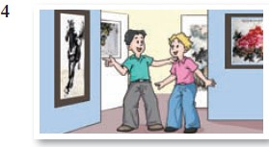
- I, learn, a bit, t’aichi, really, enjoy
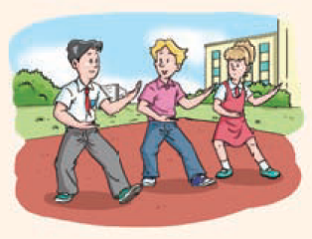

- first part, exchange student, travel, home country, stay with, family, second part, you, travel, exchange partner, stay with. family

- group, British students, Woodpark School, visit, Xinhua Junior High School,X educational exchange
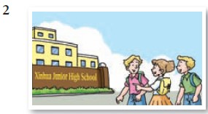

答案：
- I am glad to be a guest in my host family.
- I visited a local school and made some friends.
- We have already learnt a lot about Chinese culture and the teachers have introduced us to Chinese painting as well.
- I’ve learnt a bit of t’aichi and I really enjoy it.
- In the first part, an exchange student will travel to your home country and stay with your family. In the second part, you will travel to your exchange partner’s home country and stay with his or her family.
- A group of British students from Woodpark School are visiting Xin Hua Junior High School on an educational exchange.

