- （we, imagine, can, there be, mile, between, first, last, letter）
______________________________________________________________________________
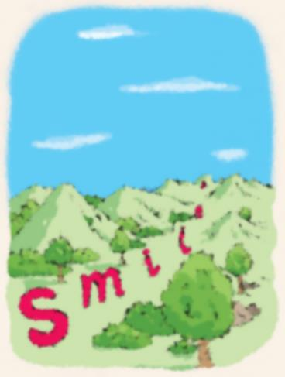

- (it, easy, remember, water cycle, step, if, understand, how, water cycle, work)
______________________________________________________________________________
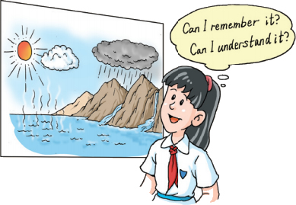
- (If, rain, tomorrow, I, watch, home)
______________________________________________________________________________

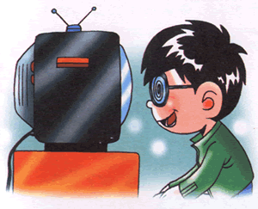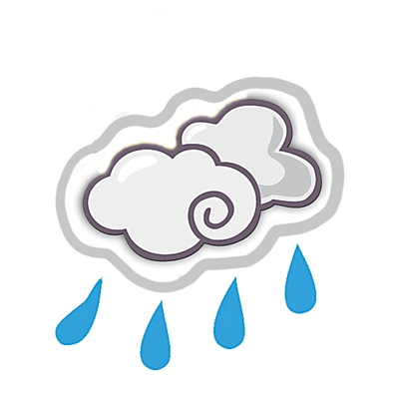
- (If, not, rain tomorrow, I, basketball)
______________________________________________________________________________
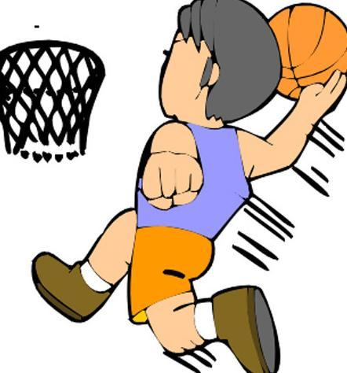

- (If, you, switch off, light, room, become dark)
______________________________________________________________________________
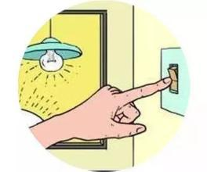
- (If, you, put, salt, water, disappear)
______________________________________________________________________________
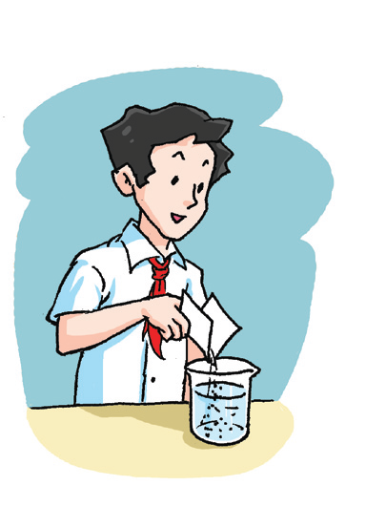
- (unless, get, enough sleep, every, night, you, remember, thing, well)
______________________________________________________________________________
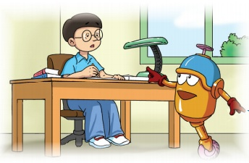
- (large number, note, pour, out, ATM, yesterday)
______________________________________________________________________________
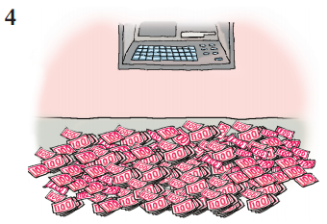

答案
- We can imagine there is a “mile” between the first letter and the last letter.
- It is easier to remember the water cycle steps if you understand how the water cycle works.
- If it rains tomorrow, I will watch TV at home.
- If it doesn’t rain tomorrow, I’ll (I can) play basketball.
- If you switch off the light(s), the room becomes dark.
- If you put salt into water, it disappears.
- Unless you get enough sleep every night, you will not remember things well.
- A large number of notes poured out of the ATM yesterday.

