看图造句练习卷
请根据图片，用所给的关键词造句。请按需加上冠词、介词、谓语动词、连词等。并使用动词和名词的正确形式。
U5单元
- I, glad, guest, host family
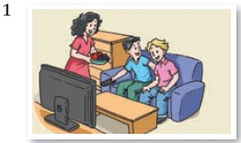
- visit, local school, make friends,
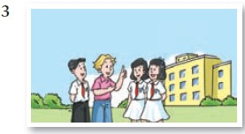
- we, already, learn, a lot, Chinese culture, teachers, introduce, Chinese painting, as well
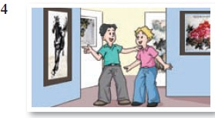
- I, learn, a bit, t’aichi, really, enjoy
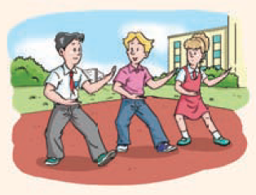

- first part, exchange student, travel, home country, stay with, family, second part, you, travel, exchange partner, stay with. family
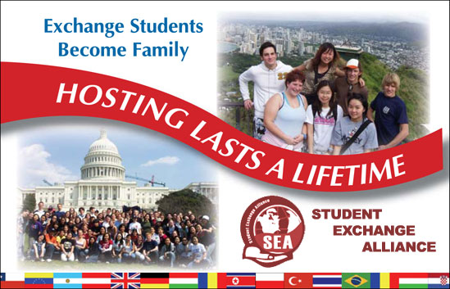
- group, British students, Woodpark School, visit, Xinhua Junior High School, Beijing, educational exchange


