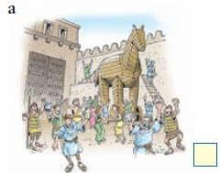
- All Trojans / sing/ dance/ around / horse/celebrate/make jokes / stupid/ Greeks.
- They/try to /capture/ our city/ten years.
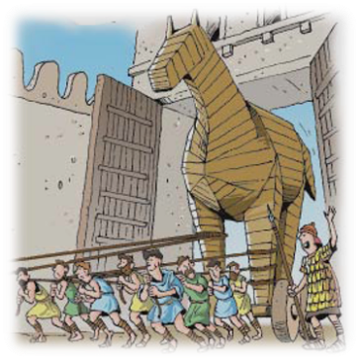
3）Trojans / horse/ into/city

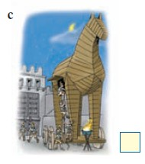
4）Greeks/ quiet/ out of / horse/ one by one

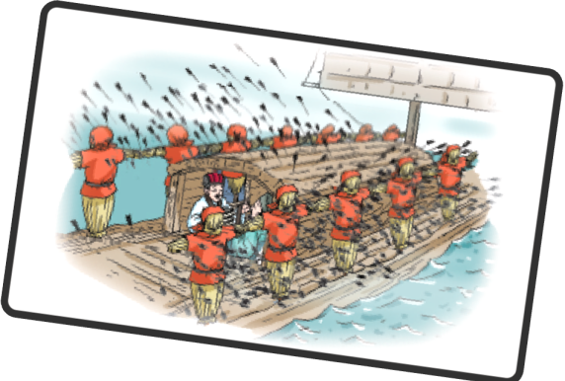
- Cao Cao /order /soldiers/ shoot/ arrows/ towards/ sounds/ drums/ shouting
- Zhuge Liang’s boats /soon/ full of/arrows.

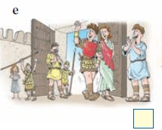
7）Everyone / Troy/ love/ Helen/ because /she/ so beautiful.
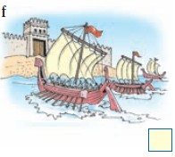
8）Many Greeks ships/ carry/ large/ Greek Army/ Troy/ get Helen back/punish/ Trojans.

1）All the Trojans sang and danced around the horse to celebrate and made jokes about the stupid Greeks.
2）They have tried to captured our city for ten years.

- Trojans pulled the horse into the city.

- Greeks quietly climbed out of the horse one by one.

- Cao Cao ordered his soldiers to shoot arrows towards the sounds of the drums and the shouting.
6）Zhuge Liang’s boats were soon full of arrows.

7）Everyone in Troy loved Helen because she was so beautiful.
8）Many Greek ships carried the large Greek Army to Troy to get Helen back and punish the Trojans.

