Handout: U8 Vocabulary Revision
- An English play: Background information
- What prince John do after being the King of England?
He increased the _____ and took all the money from _______.
- Why is Robin Hood a hero? What did he do?
He robbed the royal(皇家的) carriages to steal from ________and give _________ to the poor.
That is, he ___________________________________(劫富济贫).
③An English Play: Beginning
Little John: How did we do this week, Robin?
Robin Hood: We’ve got a little money. We had better find a rich traveller and take his gold. Let’s①____________________________________.
Little John: Let’s go. Take your ②_____, ③______ and ④______ with you.
Robin Hood: Look, here is a rock. We can ⑤______ behind it. ⑥__________, here come two men.
Little John: We should take this ⑦_______ .
Rich man’s friend: Is it safe here in the forest?
Rich men: Of course it is. I am a friend of the king–nobody would ⑧______me. Not even Robin hood!
Robin Hood: I am Robin Hood. Give me your gold.
Rich men: You can’t take the gold. It ⑨__________ the king.
Robin Hood: No, it ⑩___________ the poor.
⑤An English play: Climax and ending Mind map
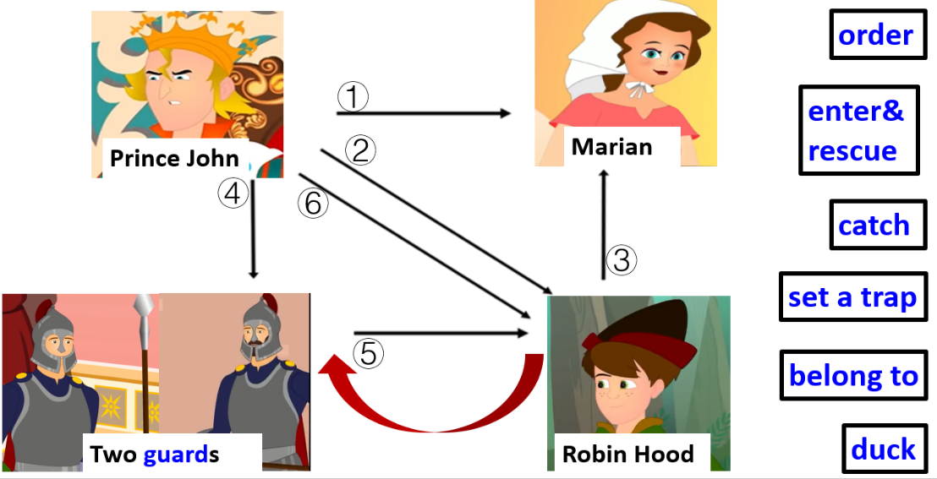

⑥Interview about the English week
Requirements(要求)：
- Work in groups of 5-6
(1) 1 Reporter(记者)
(2) 4~5 Students: Robin Hood/Prince John/Lady Marian/one of the guards/Little John
2. Use as many words/phrases from the box as possible（use at least 5 words/phrases）
3. Circle(圈出) the words/phrases you use.
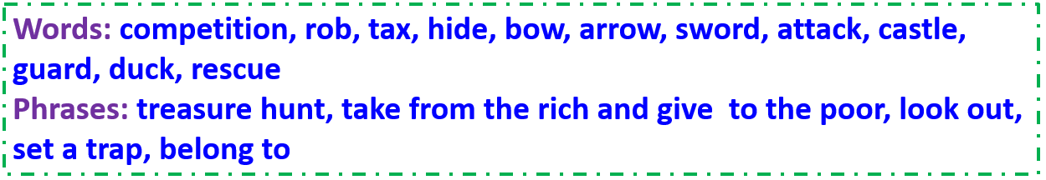
(Introduce yourself: I am…)
Reporter: Your English play was…Everybody…Can you tell me…?
S1: Sure. Our play was about … I was Robin…
Reporter: What did you do in the play?
S1: I took… and gave… One day, in the forest…
Reporter: What do you think of Robin Hood? Why?
S1: I think he’s …(brave/kind/clever…) because…
Reporter: What about S2? Who were you in the play and what…?
S2: I was Prince John. I increased… I was angry… because … And then I …
Reporter: What do you think of…? Why?
S2: He’s…(proud/cruel残忍的/evil邪恶的/greedy贪婪的/arrogant傲慢的) because…
Reporter: What about S3? Who …?
S3: I was Lady Marian. I was caught …and…
Reporter: Wow. What’s the relationship between Robin Hood and Marian?
S3: Well, they…
Reporter: What about S4? Who…? S4:…
________________________________________________________ (Add more questions here.)
________________________________________________________ (Add more questions here.)
Reporter: This play was… You are… Thank you for…

