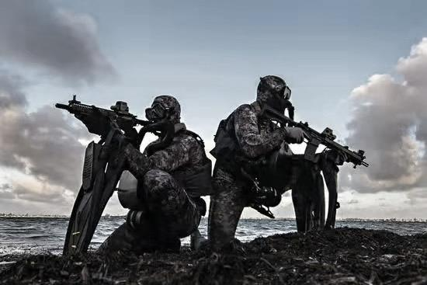
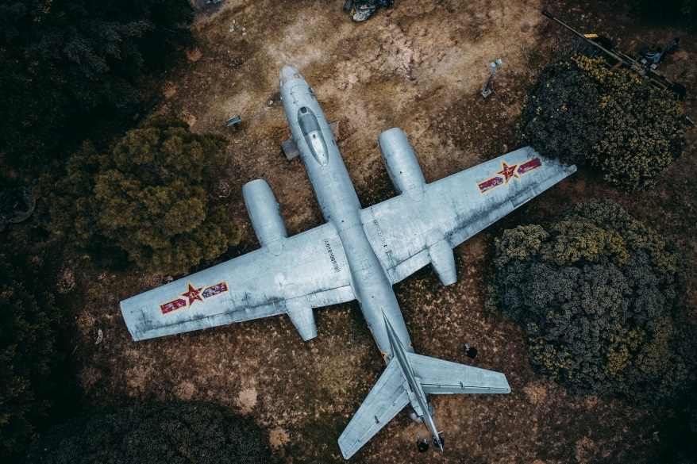
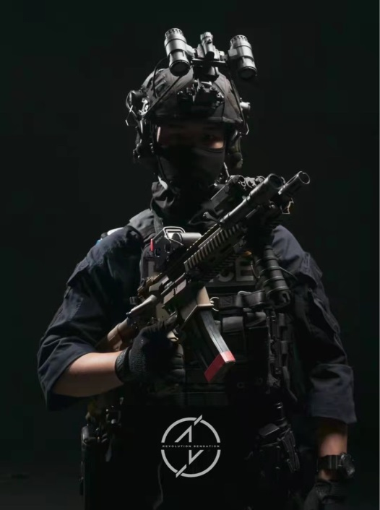
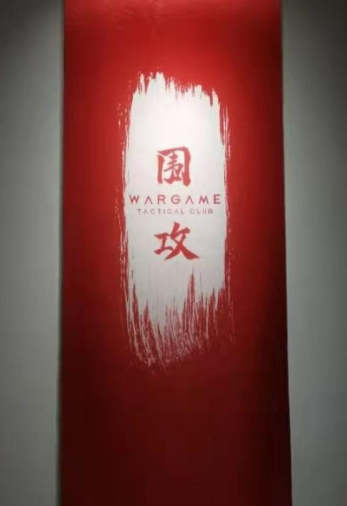
Good Luck soldiers
Other things: Lunches are served. Meet at the north gate of Sun Yat-sen University at 8 a. m. and dismiss at 6 p.m.
DAY 2:
- Morning: You’ll listen to a veteran telling his story during the war to resist US aggression and aid Korea. After his speech, you can ask some questions about the details of the war or other things.
- Afternoon: You’ll go to Siege Tactical Club to have a experience of real battlefield, under a rain of bullets.
Dates: 1 August – 2 August
Location: Guangzhou, China
DAY 1:
- Morning: You’ll go to visit Huangpu Military theme park. Many retired armament equipment can be seen there. You can even ride on a tank!
- Afternoon: You’ll learn some skills of battlefield first aid. Some professional instructors will be invited.
It’s time for you who are interested in military to take part in our summer camp!
MILITARY THEME SUMMER CAMP

