Must 让梦想突破天际
原文：But then eventually, I thought the idea of inventing things would be really cool. And the reason I thought that was because I read a quote from Arthur C. Clark which said that “A sufficiently advanced technology is indistinguishable from magic.’ And that’s really true.
译文：但最终，我认为发明事物的想法会非常酷。我之所以这么认为，是因为我读到了 Arthur C. Clark 的一句话：“足够先进的技术与魔法无异。”这是真的。
赏析：a quote用于引述别人的话；is indistinguishable from解释为“与…无异”
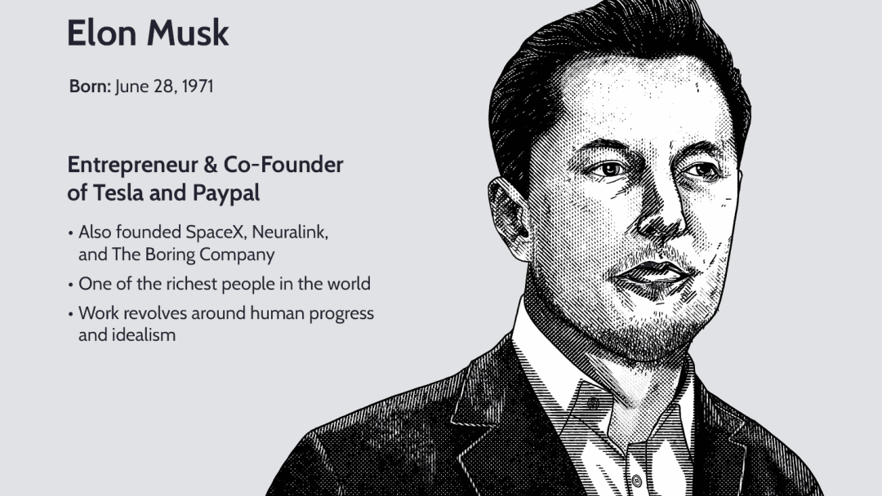
（图片来源于网络）
原文：And I thought well I could either pursue this technology, where success may not be one of the possible outcomes, which is always tricky, or participate in the Internet and be part of it. So, I decided to drop out. Fortunately, we’re pastgraduation, so, I can’t be accused of recommending that to you.
译文：而且我认为我可以去追求这项技术，尽管这很可能失败，也可能很棘手；要么投身互联网行业并成为其中的一部分。所以，我决定退学。幸运的是，我们已经毕业了，所以,，你们不能指责我带坏你们。
赏析：where success may not be one of the possible outcomes中where指代前面的technology（在这一领域内），引导非限性定语从句，后半句的which指代前面一整句话，表示追求这项技术的工作是很棘手的。
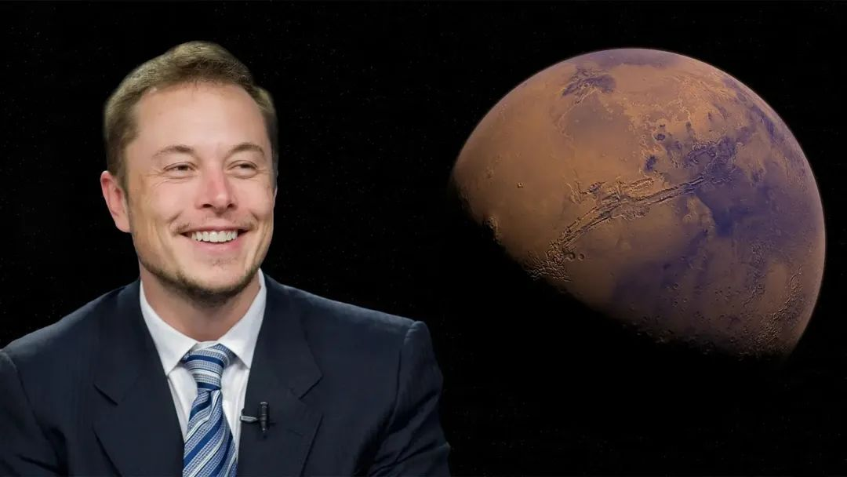
原文：Going from PayPal, I thought well, what are some of the other problems that are likely to most affect the future of humanity? It really wasn’t from the perspective of 'what’s the best way to make money,’ which is okay, but it was really 'what do I think is going to most affect the future of humanity.’
译文：基于PayPal的研发，我思考还有哪些问题可能对人类的未来影响最大？这真的不是从“什么是最好的赚钱方式”的角度来看，你们要这么想也没关系，但我真的是从“什么是对人类的未来影响最大”这个角度出发的。
赏析：Going from PayPal表示基于PayPal开发这个案例；It really was from the perspective of … 表示从…的角度出发。
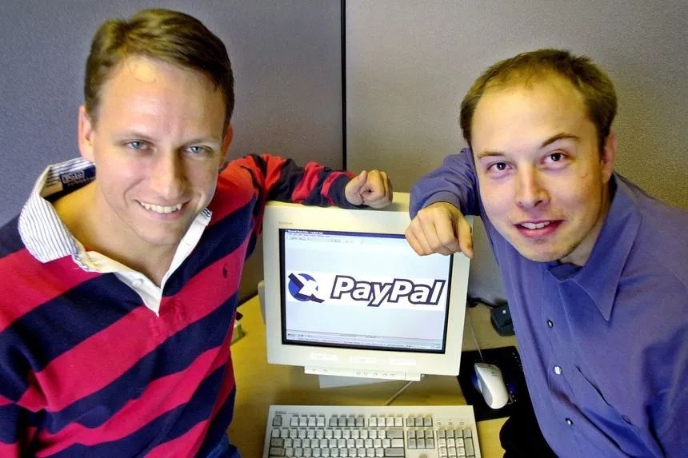
（图片来源于网络）
原文：So,I went to Russia three times to look at buying a refurbished ICBM… because that was the best deal. And I can tell you it was very weird going there in late 2001-2002 going to the Russian rocket forces and saying, 'I’d like to buy two of your biggest rockets, but you can keep the nuke.’
译文：所以，我去了三趟俄罗斯，考虑购买翻新的洲际弹道导弹……因为那是最好的交易。我在2001年年底去了俄罗斯火箭部队并问他们：“我想向你们购买两枚最大的火箭，但你们可以保留核武器，这太疯狂了。”
赏析：a refurbished ICBM解释为翻新的洲际导弹（Intercontinental Ballistic Missile）；it was very weird doing sth解释为做某事很疯狂、不可理喻。
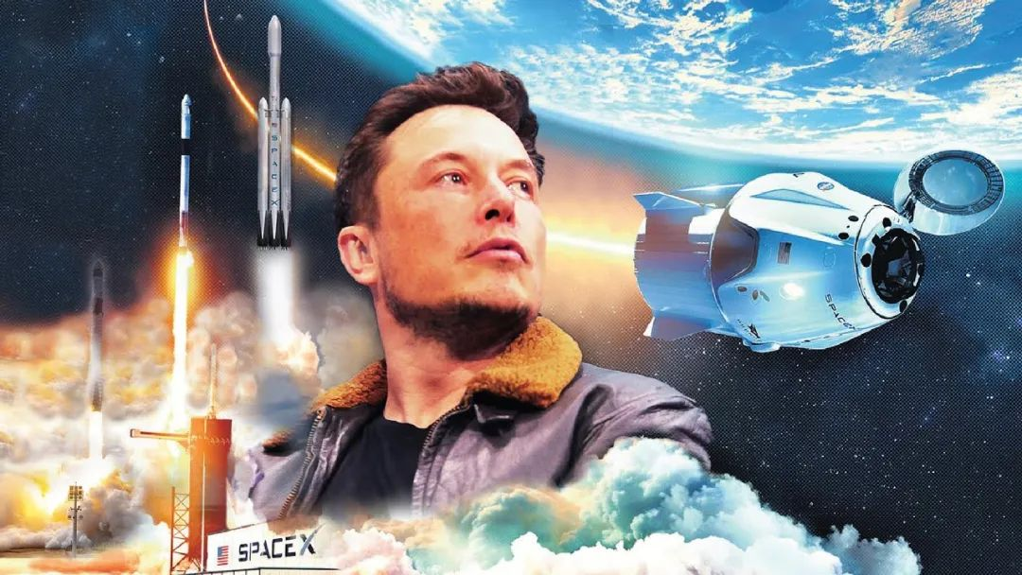
原文：Because after we made the Tesla Roadster people said, 'oh sure, sure we always knew you could make a car like that, it’s an expensive car and it’s low volume and small and all that but can you make a real car?’ Okay, fine, we’re going to make that, too. So, that’s coming out soon.
译文：因为在我们制造了Tesla Roadster 之后，人们说：“哦，当然，我们一直都知道你可以制造出这样的汽车，这是一辆昂贵的汽车，而且体积小等等，但你真的能把它造出来吗？”好吧，好吧，我们会付诸行动的。所以，它很快就会被制造出来。
赏析：we always knew you could make a car like that中could是虚拟语态，表示说话的人觉得马斯克的想法是纸上谈兵；but can you make a real car? 中的car指代马斯克提出的概念车型。
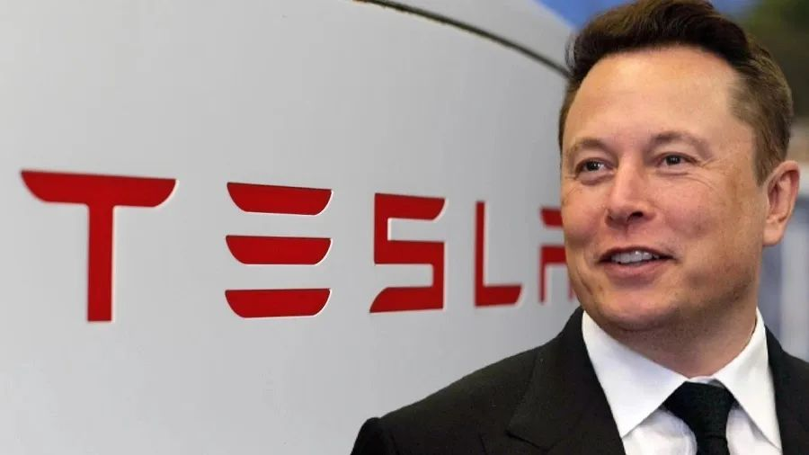
（图片来源于网络）
原文：I think the overreaching point I want to make is that: You guys are the magicians of the 21st century. Don’t let anything hold you back. Imagination is the limit. Go out there and create some magic.
译文：我想做个总结：你们是21世纪的魔术师，不要让任何事情阻碍你，大胆去想象，去创造一些魔法。
赏析：the overreaching point解释为全局性观点、总结性观点；Imagination is the limit中的limit其实是说“你们不要被现实所局限，要用想象力突破限制”

